

PRESENTING SUPERNOVA
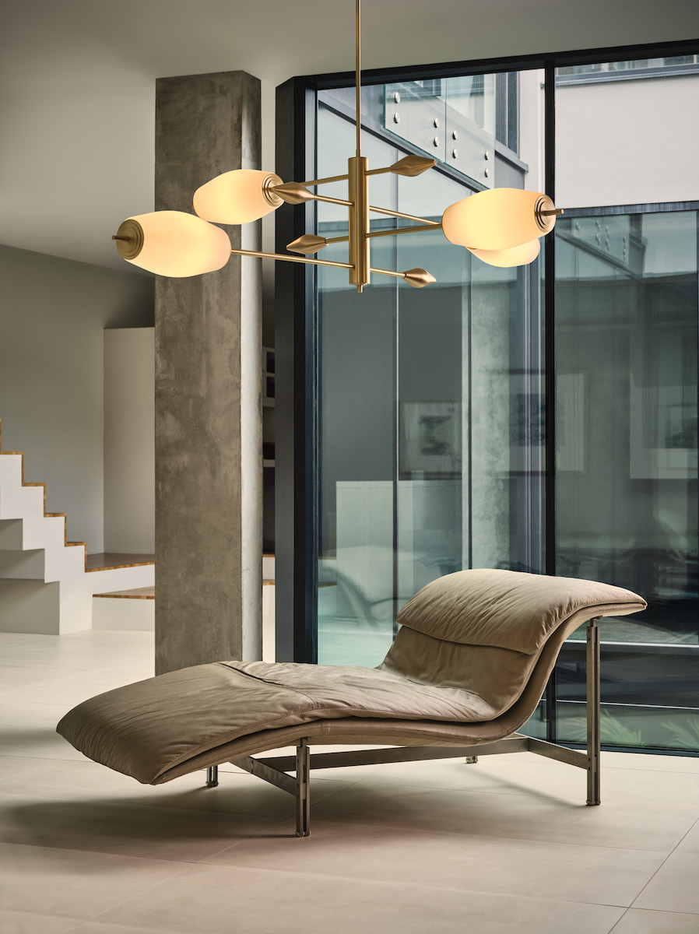

British lighting brand J. Adams & Co. preview Supernova, a capsule collection of configurable, centrepiece pendant lights launching in Spring 2022

Introducing the Supernova, a capsule collection of entirely configurable statement pendants. Made with J. Adams & Co’s trademark precision engineering, the new luminaires are a considered expansion of the best-selling Nova range. Designed to give complete control and versatility, the Supernova is comprised of solid brass cantilevered arms that can be effortlessly configured into 2,3 or 4-arm formations.

“We wanted to make the Supernova usable in a variety of contexts and spaces. The 2-arm version takes a linear form that sits perfectly over counters, desks, or long dining tables. The 3-arm version is designed to work as a central statement with a sizeable diameter spanning over a meter, and the 4-arm option is ideal for enhancing larger, open plan interior spaces and lobbies,“ explains Design Director Will Earl.

The sandblasted elliptical shades are beautifully translucent, offering a warm diffused illumination when lit, and sculptural elegance when off. Echoing the Nova collection, each shade features stepped Deco detailing, skilfully machined at the brand’s Birmingham-based factory, alongside solid tapered counterweights to provide equilibrium.

Available in four exclusive finishes, antique brass, bronze and new satin brass and satin nickel, the Supernova appeals to both residential and commercial design alike.

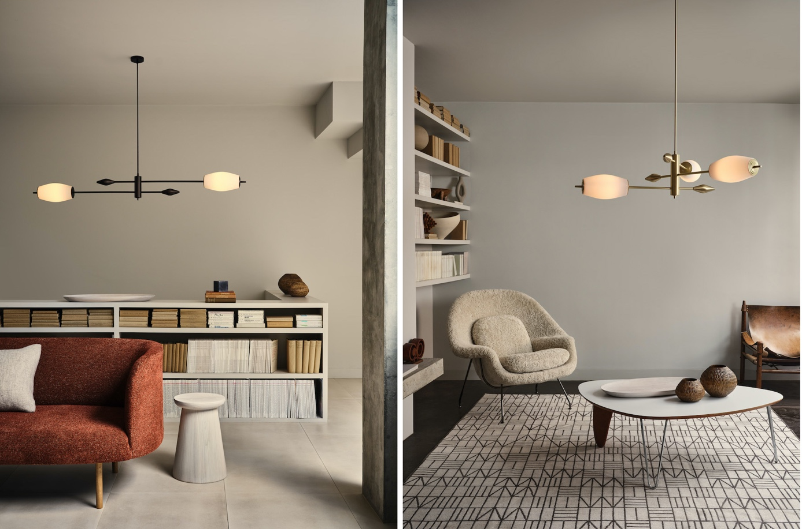
Supernova will launch online at www.jadamsandco.com in March 2022 with prices starting from £2100 (inc. VAT)

For high resolution imagery, quotes and product loans, please contact: press@jadamsandco.com | +44 (0) 7734 689511

J. Adams & Co. | www.jadamsandco.com | +44 (0)207 164 6418 | @jadamsandco

Notes to Editors
Founded in 2016 and led by Creative Director Will Earl, J. Adams & Co. showcase craftsmanship, innovative engineering and authentic design made in Britain. Combining an industrial aesthetic with modern elements, J. Adams & Co. redefine classic styles in contemporary form to create their timeless collections. Materiality and manufacturing expertise are at the heart of the brand, with each product made by hand in the companies UK Birmingham factory using only the highest quality materials.

